AutoML Modeling Report | 
Nayef Alhunaiti

Binary Classifier with Clean/Balanced Data

Train/Test Split  How much data was used for training? How much data was used for testing? | I used 80% of my data for training and 20% for testing.
Confusion Matrix  What do each of the sections in the confusion matrix describe? What values did you observe (include a screenshot)? What is the true positive rate for the “pneumonia” class? What is the false positive rate for the “normal” class? | True Positives: Correctly predicted cases for each class (diagonal elements).  False Positives: Incorrectly predicted as a specific class (off-diagonal elements in the row of the predicted class).  True Negatives: Correctly predicted as not belonging to a specific class.  False Negatives: Incorrectly predicted as another class instead of the actual class (off-diagonal elements in the row of the true class).  Observed Values:  - Bacterial Pneumonia (TP): 1.00 (Perfectly classified as bacterial pneumonia).  - Normal (TP): 1.00 (Perfectly classified as normal).  - Viral Pneumonia (TP): 0.70 (70% correctly classified as viral pneumonia).  - Viral Pneumonia Misclassified as Bacterial Pneumonia (FP): 0.10  - Viral Pneumonia Misclassified as Normal (FP): 0.20  True Positive Rate (TPR) for "Pneumonia" Class:  - Bacterial Pneumonia: 1.00  - Viral Pneumonia: 0.70  False Positive Rate (FPR) for "Normal" Class:  - Normal Misclassified as Pneumonia: 0.20 (from viral pneumonia cases incorrectly classified as normal).  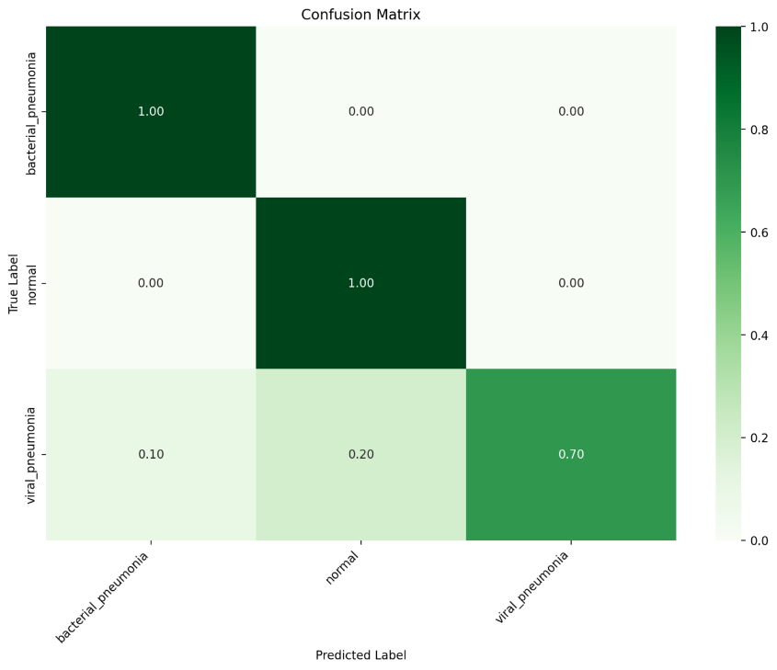
Precision and Recall  What does precision measure? What does recall measure? What precision and recall did the model achieve (report the values for a score threshold of 0.5)? | Precision:  - Bacterial Pneumonia: 1.00  - Viral Pneumonia: 0.875  - Normal: 0.833  Recall:  - Bacterial Pneumonia: 1.00  - Viral Pneumonia: 0.778  - Normal: 1.00

Binary Classifier with Clean/Unbalanced Data

Train/Test Split  How much data was used for training? How much data was used for testing? | I used 80% of my data for training and 20% for testing.
Confusion Matrix  How has the confusion matrix been affected by the unbalanced data? Include a screenshot of the new confusion matrix summary | The unbalanced data has caused the model to have a high false positive rate for the "normal" class while maintaining a high recall (1.00) for the "pneumonia" class.  The precision for "pneumonia" is likely high, but the precision for "normal" is reduced due to many normal cases being misclassified as pneumonia.  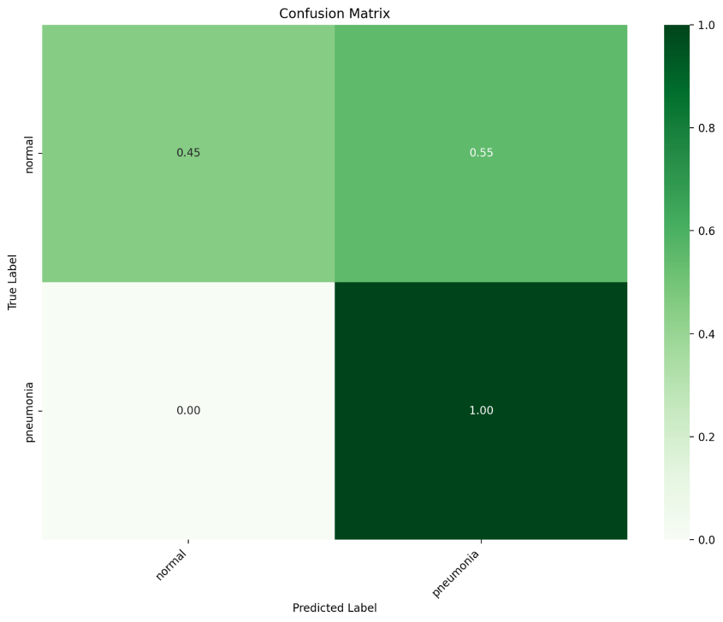
Precision and Recall  How have the model’s precision and recall been affected by the unbalanced data? | Precision:  - Normal: Decreased due to many normal cases being misclassified as pneumonia.  - Pneumonia: Likely remains high, but the exact impact depends on the number of false positives.  Recall:  - Normal: Decreased significantly (only 45% of normal cases correctly identified).  - Pneumonia: Perfect recall (1.00), but at the expense of normal cases.
Unbalanced Classes  From what you have observed, how do unbalanced classed affect a machine learning model? | The unbalanced data causes the model to overfit to the more frequent class (pneumonia), leading to poor performance on the minority class (normal), especially in terms of recall and precision for that class, and it can lead to biased models that perform well on the majority class but poorly on the minority class. Careful handling of class imbalance is essential to ensure a model that generalizes well and performs effectively across all classes.

Binary Classifier with Dirty/Balanced Data

Confusion Matrix  How has the confusion matrix been affected by the dirty data? Include a screenshot of the new confusion matrix information. | - Precision: Likely reduced, especially for the normal class, as a larger number of normal cases are misclassified.  - Recall: Also likely reduced for the normal class, as fewer normal cases are being correctly identified.  The dirty data has led to a significant drop in the model's ability to correctly classify both normal and pneumonia cases, which is reflected in the increased error rates (false positives and false negatives).  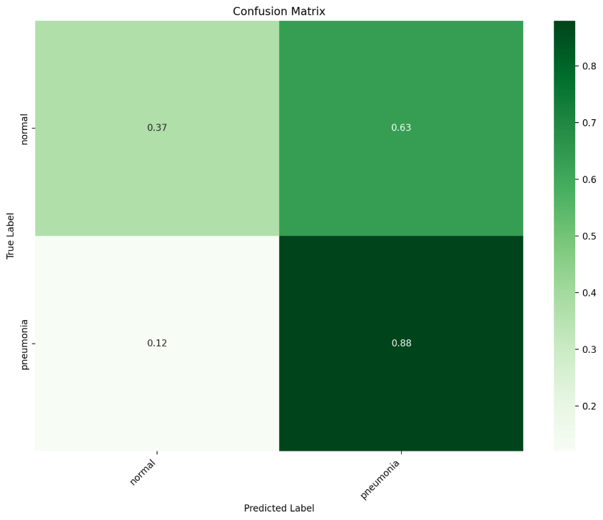
Precision and Recall  How have the model’s precision and recall been affected by the dirty data. Of the binary classifiers, which has the highest precision? Which has the highest recall? | - Highest Precision: The clean data confusion matrix shows a higher precision for ‘Pneumonia’ (0.65) compared to the dirty data.  - Highest Recall: The clean data confusion matrix also shows a perfect recall for ‘Pneumonia’ (1.00), which is higher than the recall from the dirty data (0.88).  the clean data has improved both the precision and recall for the ‘Pneumonia’ class, indicating better model performance with less misclassification.
Dirty Data  From what you have observed, how does dirty data affect a machine learning model? | - Reduced Accuracy: Leads to more incorrect predictions.  - Increased Misclassification: Higher rates of false positives and false negatives.  - Bias Introduction: Can skew the model towards certain classes.  - Lower Precision and Recall: Decreases the reliability of predictions.  - Poor Generalization: Model performs poorly on new, clean data.  - Increased Training Time: Requires more resources to train.  - Difficulty in Interpretation: Harder to understand model decisions.

3-Class Model

Confusion Matrix  Summarize the 3-class confusion matrix. Which classes is the model most likely to confuse? Which class(es) is the model most likely to get right? Why might you do to try to remedy the model’s “confusion”? Include a screenshot of the new confusion matrix information. | - Most Likely to Confuse: The model confuses ‘Normal’ with ‘Bacterial Pneumonia’ or ‘Viral Pneumonia’ (0.00 true positives for ‘Normal’).  - Most Likely to Get Right: The model correctly identifies ‘Bacterial Pneumonia’ (1.00 true positives).  Remedies:  - Data Balancing: Ensure equal representation of all classes.  - Feature Engineering: Improve features to better distinguish classes.  - Hyperparameter Tuning: Optimize model settings.  - Cross-Validation: Validate model performance on different data subsets.  - Data Augmentation: Increase samples for underrepresented classes.  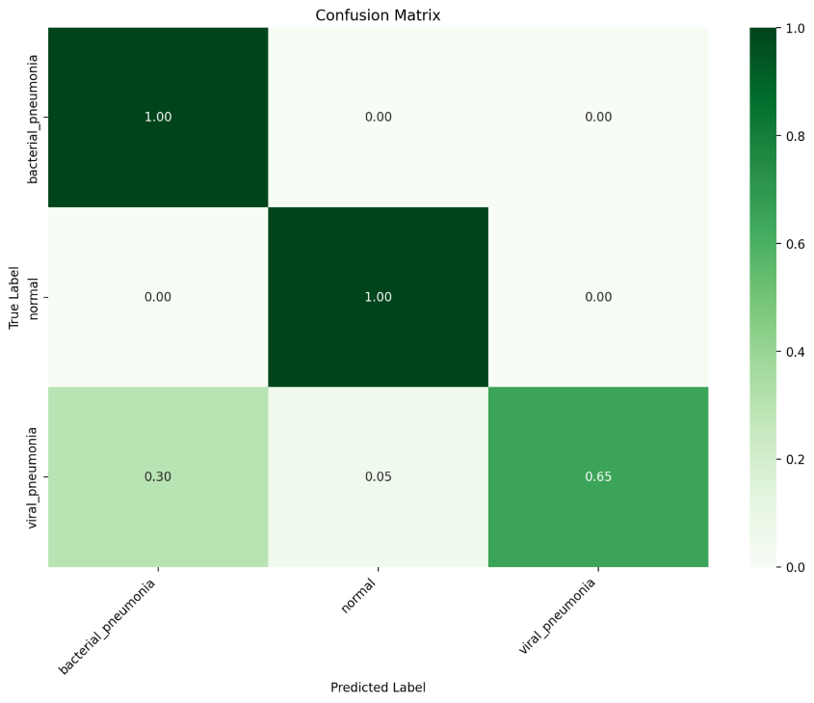
Precision and Recall  What are the model’s precision and recall? How are these values calculated? | - Bacterial Pneumonia: Precision = 1.00, Recall = 1.00  - Normal: Precision = 0.00, Recall = undefined  - Viral Pneumonia: Precision ≈ 0.93, Recall ≈ 0.68  - Macro Precision = (1.00 + 0.00 + 0.93) / 3 ≈ 0.64  - Macro Recall = (1.00 + 0.68) / 2 ≈ 0.84  For weighted averages, the "Normal" class is excluded for recall calculations because its recall is undefined.  Total number of instances for weighted recall = Support for Bacterial Pneumonia + Support for Viral Pneumonia = 1 + 0.7 = 1.7  - Weighted Precision = (1.00 × 1 + 0.93 × 0.7) / (1 + 0 + 0.7) ≈ 0.96  - Weighted Recall = (1.00 × 1 + 0.68 × 0.7) / 1.7 ≈ 0.85
F1 Score  What is this model’s F1 score? | Since the F1 score for the "Normal" class is undefined, we'll exclude it from the macro average:  Macro F1 Score: ≈ 0.895  Weighted F1 Score: ≈ 0.88

